**AEM Template and Page Creation**

In this part of the tutorial, will build a new Article Page Template that can be used to create new article pages and aligns with a common structure. The Article Page Template will be based on designs and a UI Kit produced in AdobeXD. This chapter is only focused on building out the structure or skeleton of the template. No styles will be implemented but the template and pages will be functional.

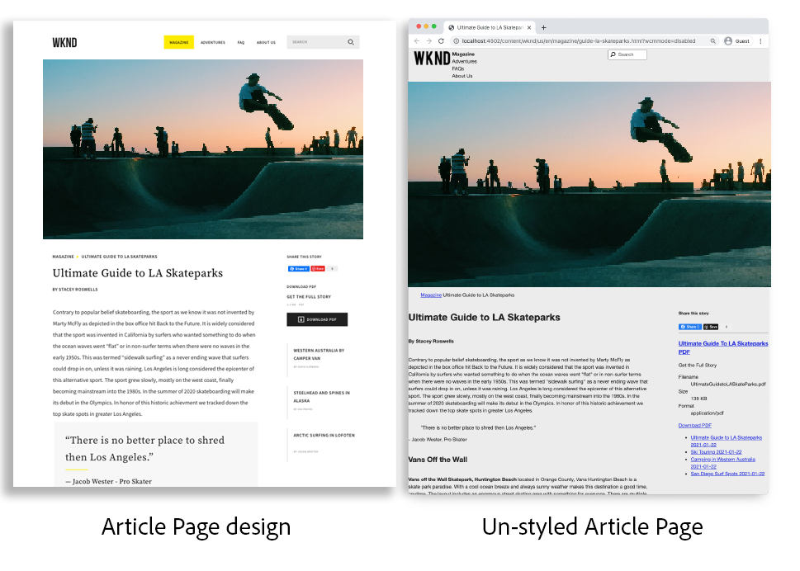

**Update the Header and Footer with Experience Fragments**

A common practice when creating global content, such as a header or footer, is to use an Experience Fragment. Experience Fragments, allows users to combine multiple components to create a single, reference-able, component. Experience Fragments have the advantage of supporting multi-site management and localization.

The AEM Project Archetype generated a Header and Footer. Next, update the Experience Fragments to match the mockups.

**Project generation:**

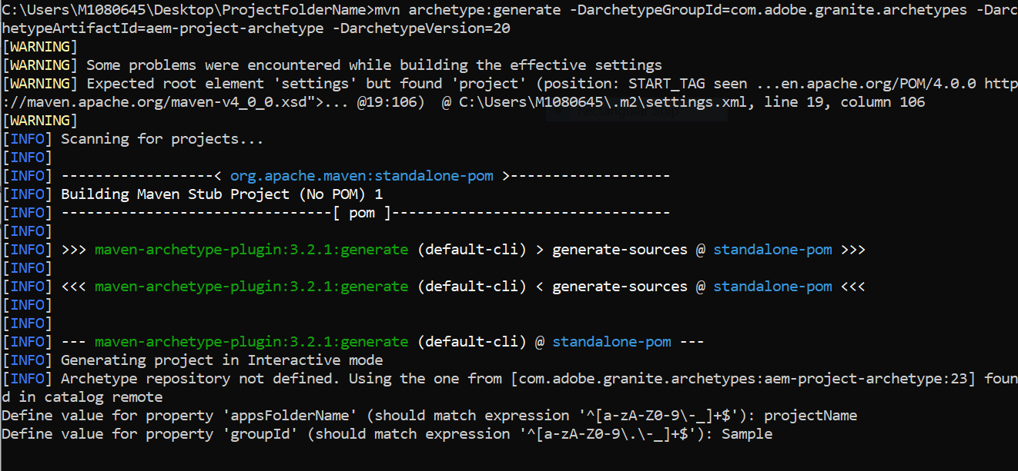

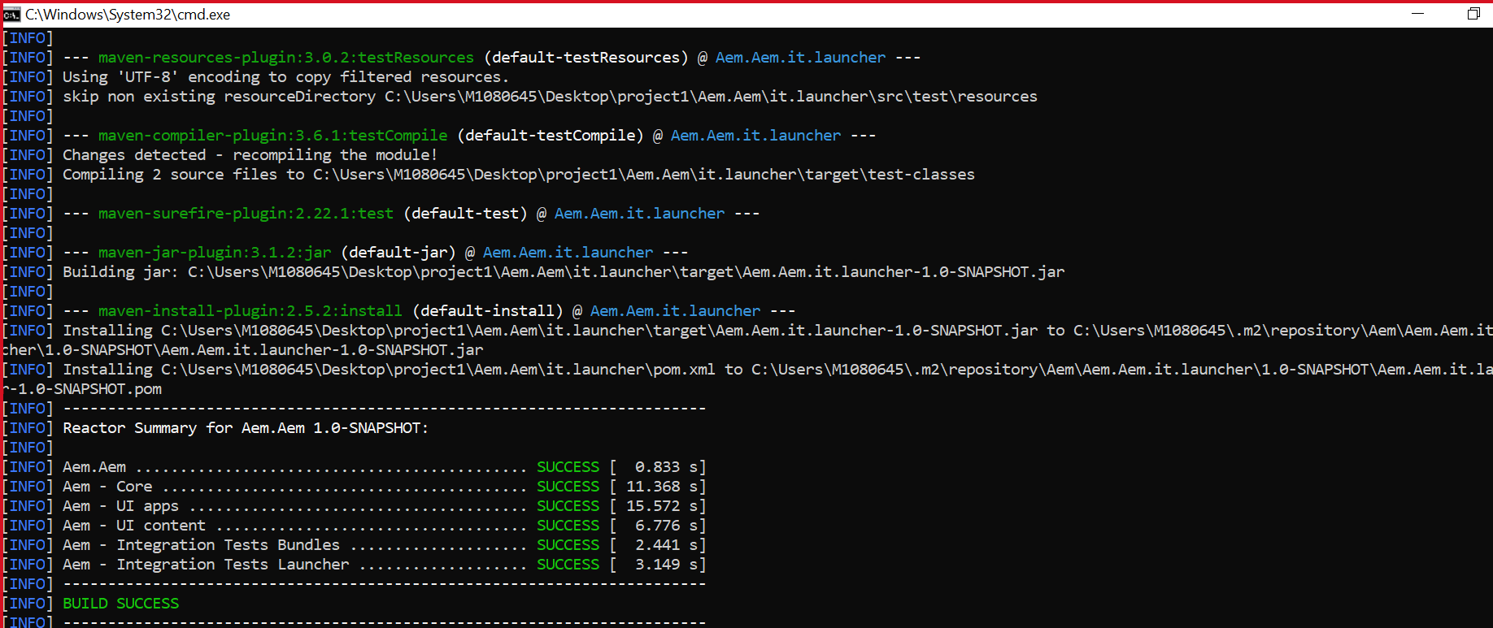

**Updating Package on CRX:**

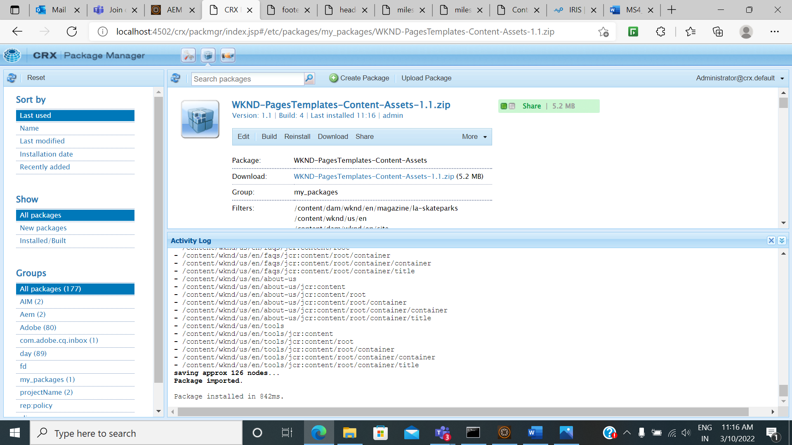

**Article Page :**

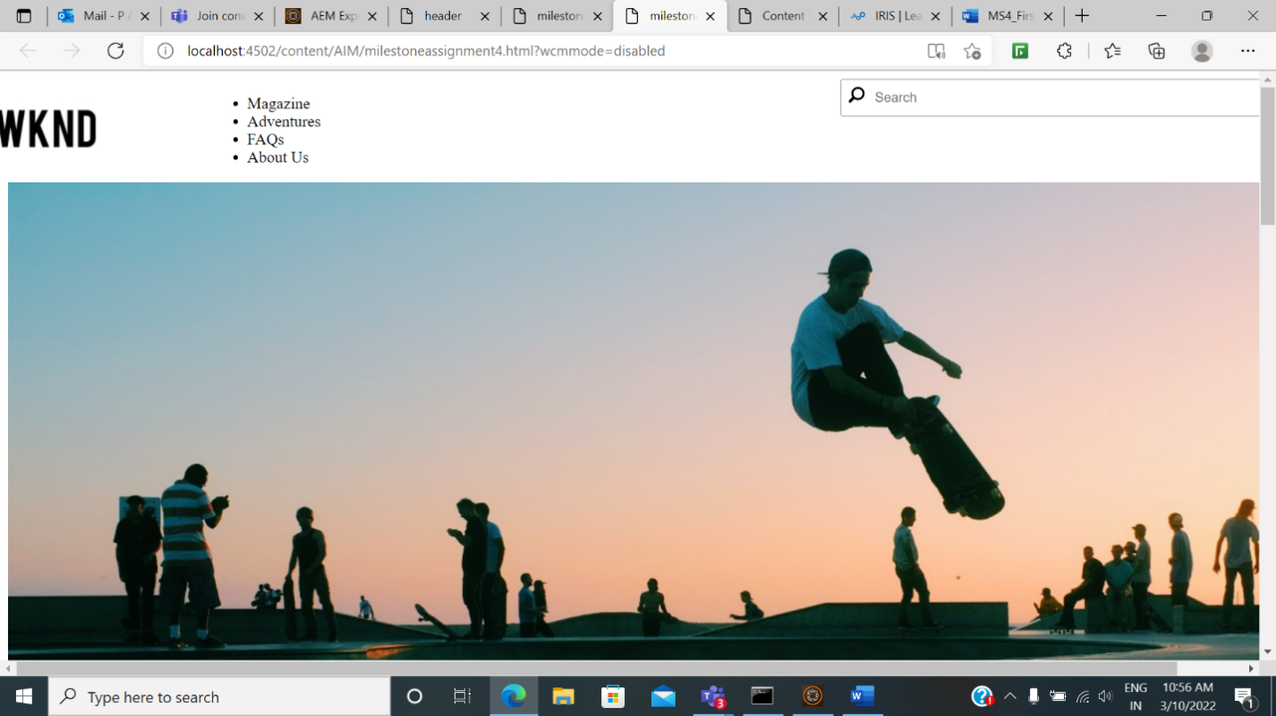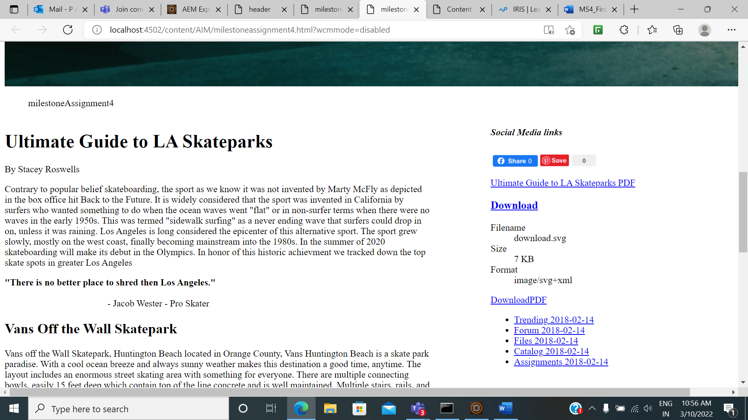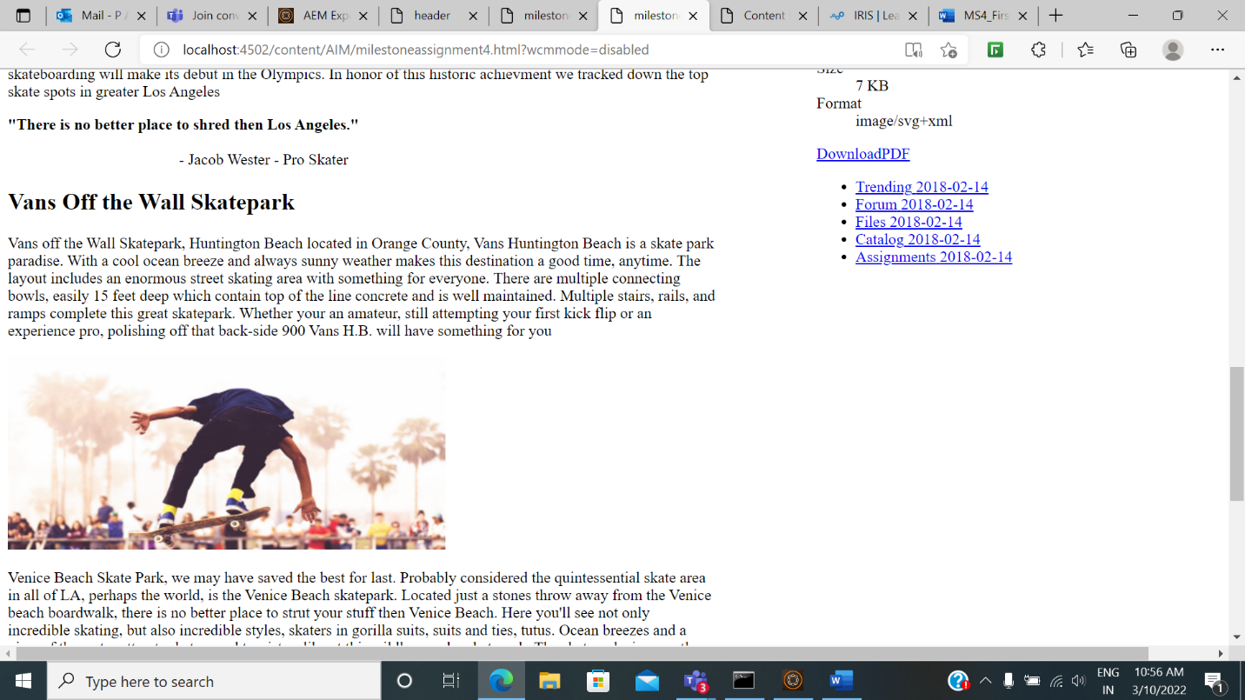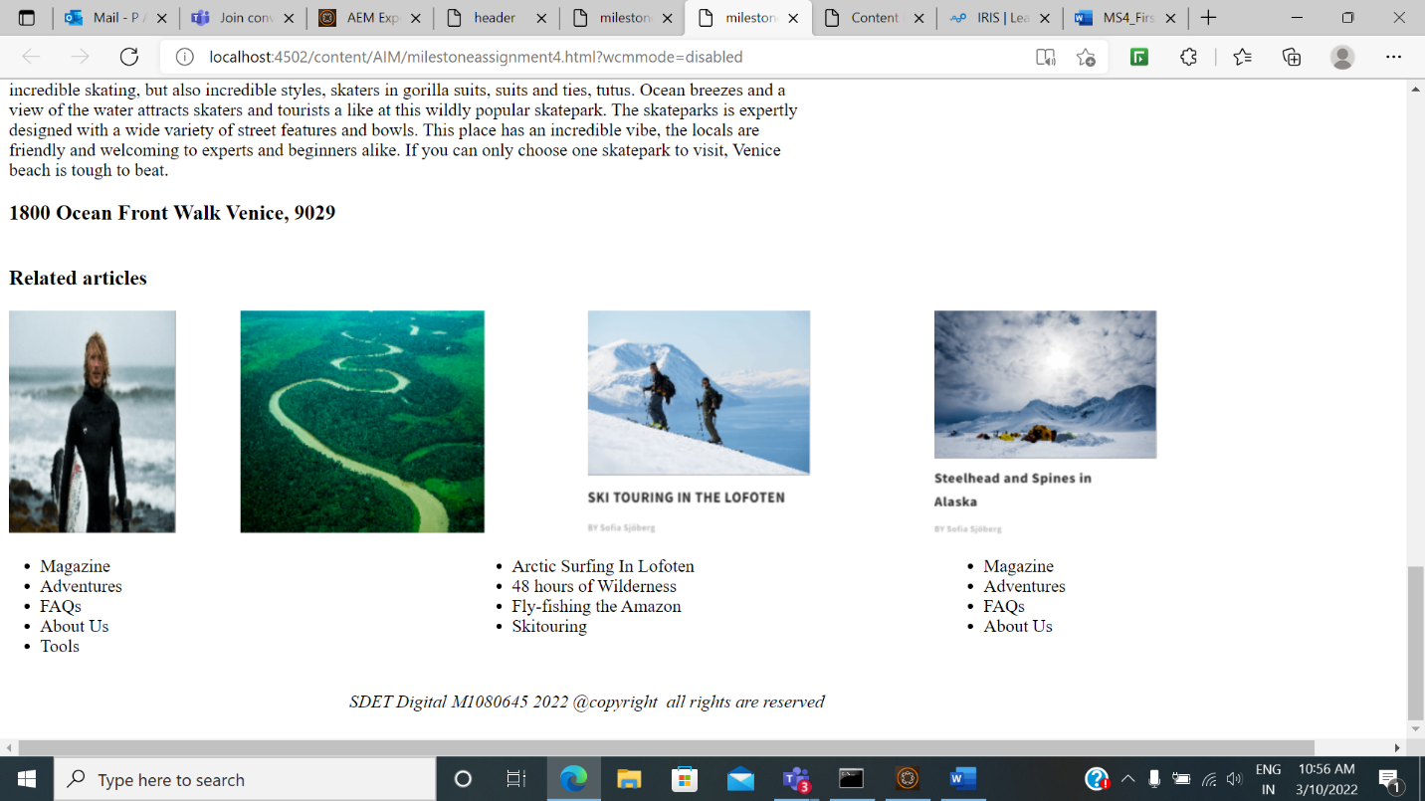

**Editable Page:**

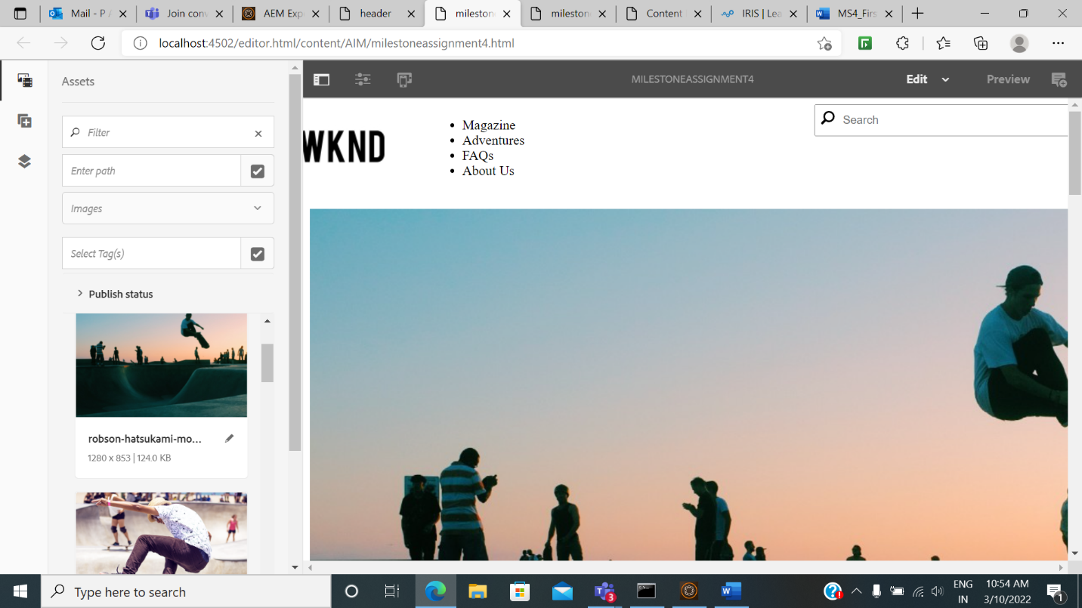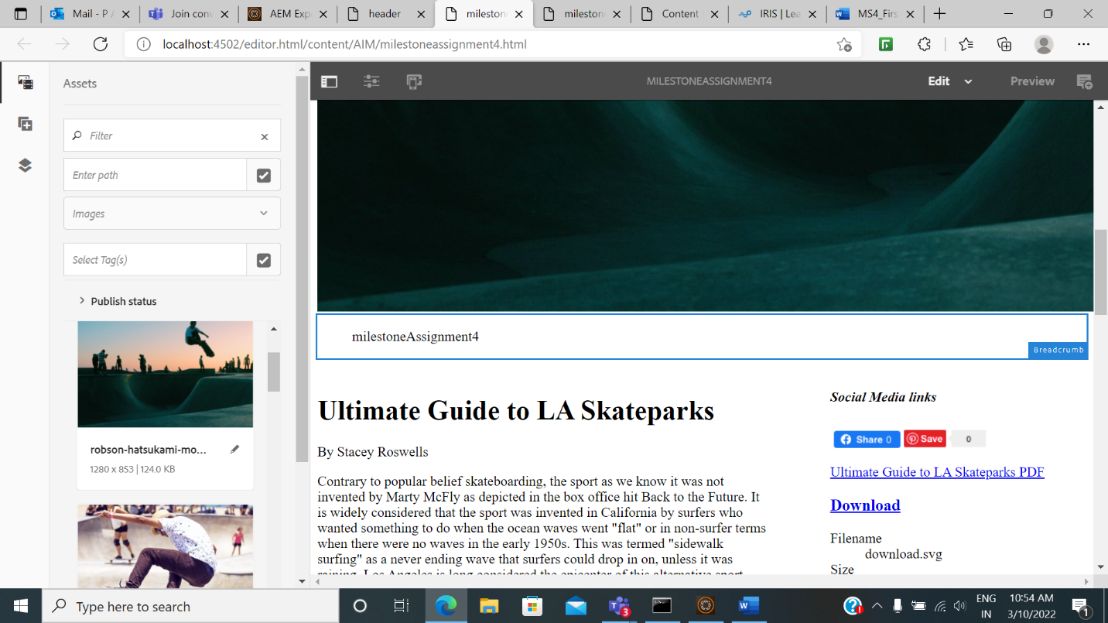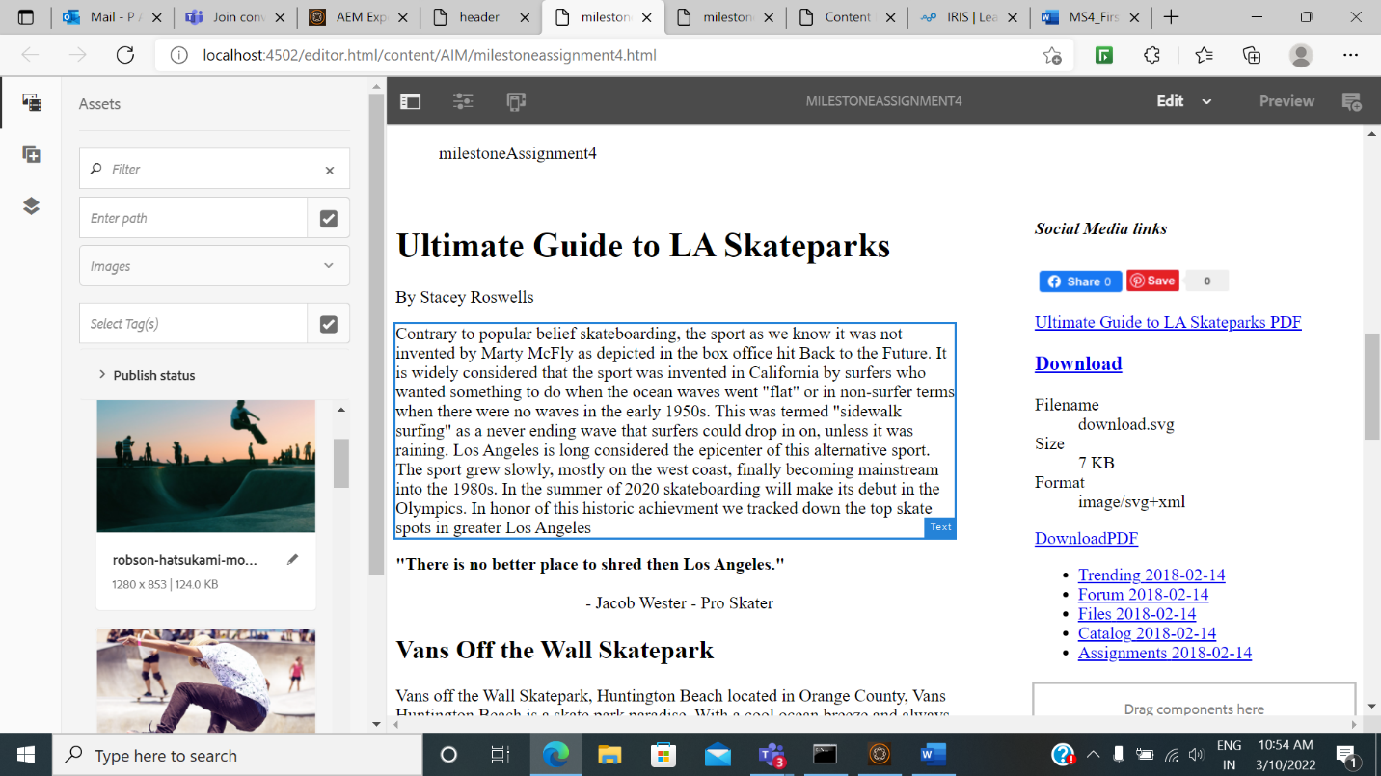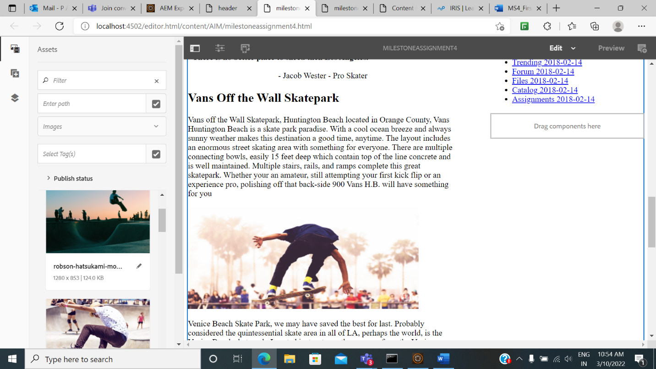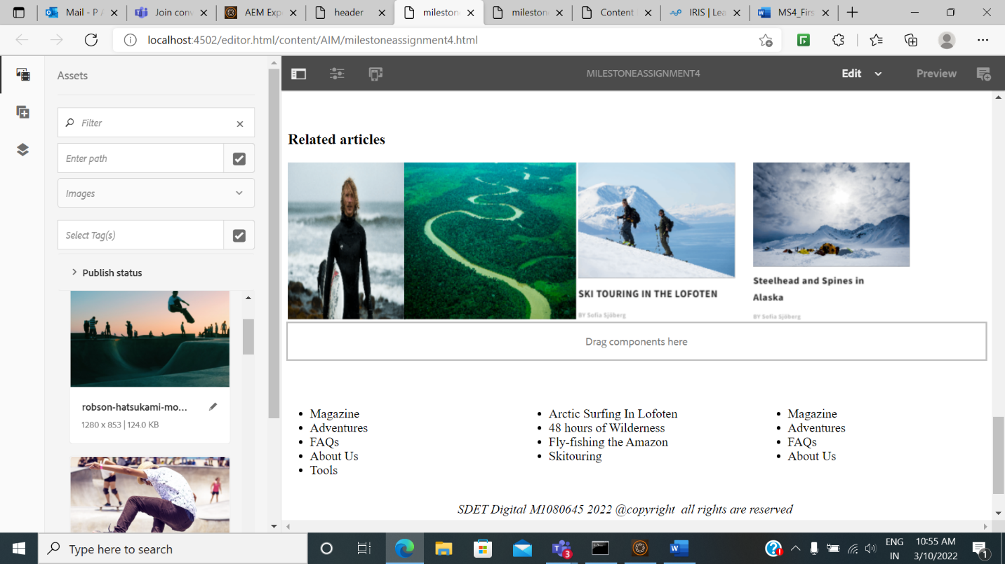

**Experience Fragment::]**

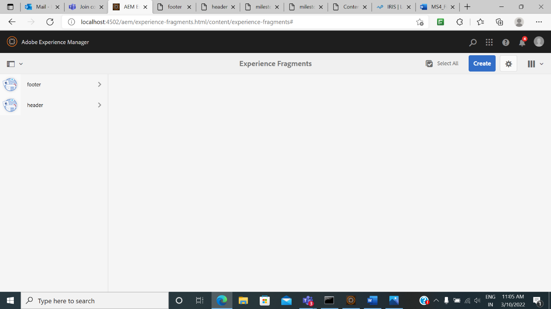

**Experience fragment header:**

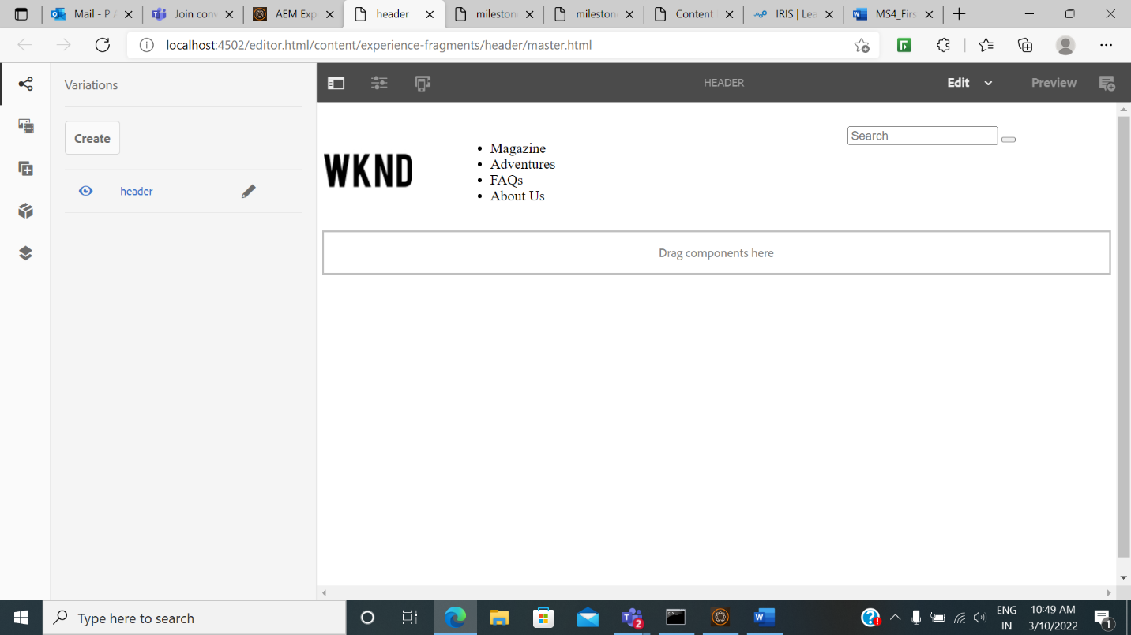

**Experience Fragment footer:**

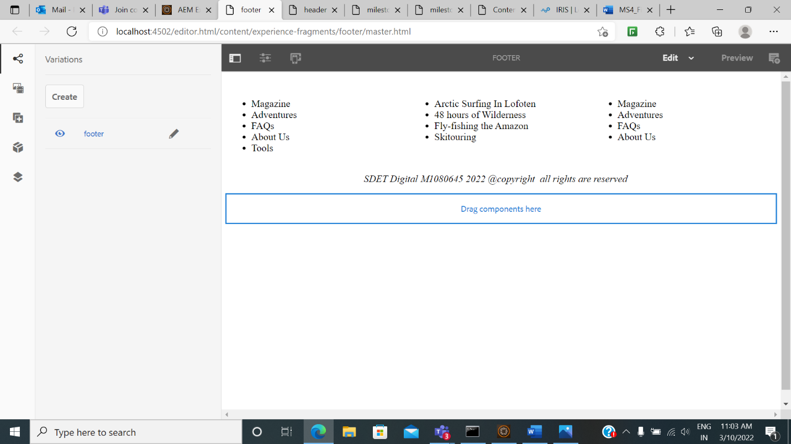

**Template for the page:**

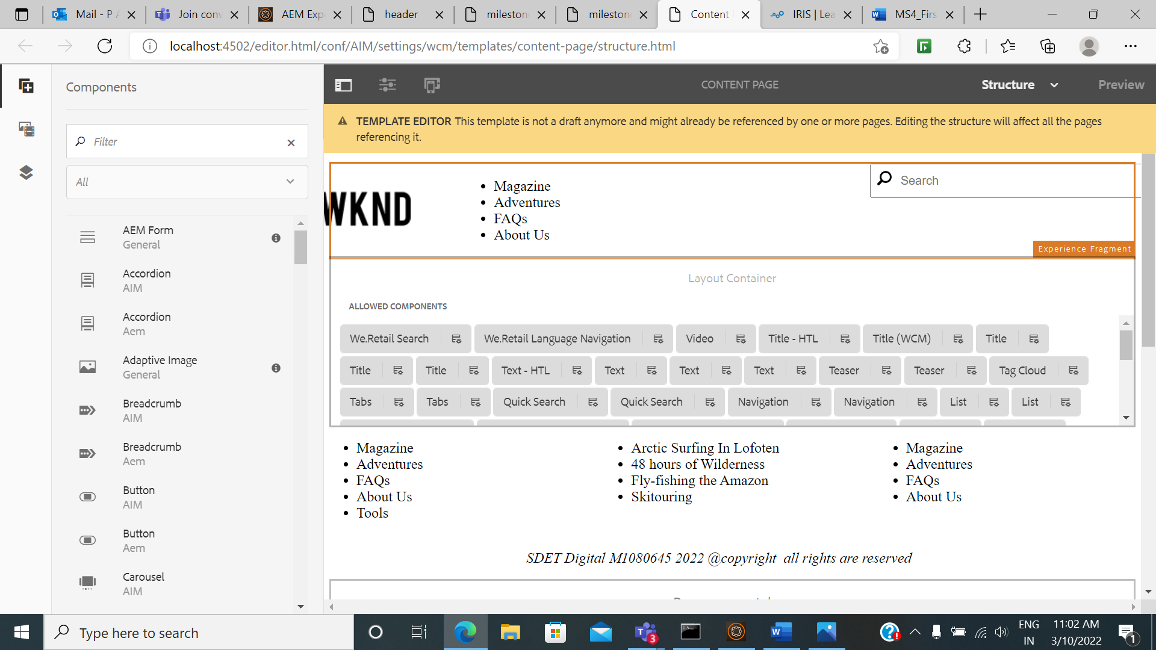

**Responsive page:**

